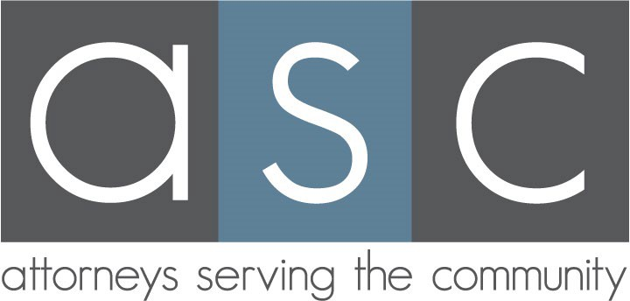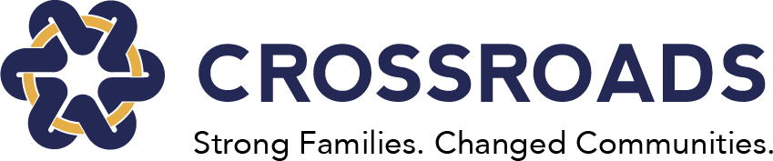

ASC Co-Chairs
Jennifer Klein Ayers 214.914.3812
jayers@sheppardmullin.com

Devon Sharp 214.364.4876
devon.sharp@galderma.com

Silent Auction Co-Chairs
Tiffany Lam-Bentley tlambentley@bal.com

Jigyasa Singla jigyasa@leboeuflaw.com

Anne Sparks anne.sparks@thermon.com

2023-2024 Beneficiary Crossroads Community Services
Benaye Wadkins Chambers President & CEO bwadkinschambers@ccsdallas.org

Cynthia Thompson
VP of Development & Engagement cthompson@ccsdallas.org

Taylor Hall Chief of Staff
thall@ccsdallas.org

Dear ASC Member:

Thank you so much for being a part of Attorneys Serving the Community (“ASC”)!

As you know, ASC has chosen Crossroads Community Services (“Crossroads”) as ASC’s 2023-2024 beneficiary. Crossroads, a 501(c)(3) non-profit organization, is the leading hunger relief provider in Southern Dallas County. Crossroads supports economic stability and health for low-income households through generous, accessible, and nutrition-focused food assistance. With the support of its distribution partners, including Feeding America, last year Crossroads distributed approximately 11 million pounds of food – enough for 9,166,666 meals – to households in Dallas, Ellis, and Navarro counties. This year, Crossroads anticipates distributing an incredible 20 million pounds of food.

This year, Crossroads and ASC are partnering to raise funds to launch a Nutrition Pharmacy, among other initiatives. Partners at UT Southwestern Medical Center, Parkland Health, and Children’s Health will pre-screen patients at their RedBird facilities for food security, and then provide referrals or Food Prescriptions for groceries for the entire household that can be used at Crossroads’ satellite Market, just a few steps away. You can learn more about these programs at: https://ascdallas.com/asc-crossroads.

On April 25, 2024, ASC will host an online and in-person Silent Auction benefitting Crossroads at the new state-of-the-art headquarters of the law firm of Munsch Hardt Kopf & Harr, P.C. on the 40th floor of Ross Tower in downtown Dallas. A big thank you to Munsch Hardt for hosting this event! The Silent Auction is a great opportunity to get your Barbie on, get all dolled up and go to headquarters to raise much-needed funds for those in need in our community. Please feel free to wear either your highest pink heels or your Birkenstocks – you will be welcome!

In the meantime, please consider supporting ASC and Crossroads by making an in-kind donation to be sold at the Silent Auction, a cash donation toward underwriting the expenses associated with this event, or donating wine valued at $15 or more or restaurant gift cards valued at $25 or more for the ever popular wine pull and restaurant grab at our Silent Auction. We are happy to discuss donation items and/or specific event underwriting at your convenience. We can make arrangements for a member of the ASC Silent Auction Committee to pick up in-kind donations, or you can mail donations directly to the attention of: Crossroads Community Services, c/o Taylor Hall, 4500 South Cockrell Hill Road, Dallas, TX 75236. As noted above, Crossroads will receive 100% of the proceeds (net of expenses) from the Silent Auction. Each of our sponsors and donors will be recognized for their support of ASC and Crossroads and can attend and participate in this lively, in-person community event.

If I can answer any questions or be of any assistance, please do not hesitate to contact me. Thank you in advance for your support!

Sincerely,

ASC Silent Auction Committee

